**SpoCo North West**

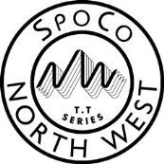



Time Trial Series

2016

|  |  |  |  |  |
| --- | --- | --- | --- | --- |
| **Date** | **Day** | **Course** | **Distance** | **Club** |
| 20th March | Sunday | J8/2R | 17 miles | Crewe Clarion Wheelers |
| 25th March | Friday | J8/3 | 33 miles (men / espoirs)  22 miles (women / juniors) | Buxton Cycling Club |
| 17th April | Sunday | J8/4 | 26 miles | Glossop Kinder Velo |
| 18th May | Wednesday | J8/7R | 18 miles | Saddleworth Clarion |
| 15th June | Wednesday | O17C | 18 miles | Peak Road Club |
| 26th June | Sunday | J8/25 | 21 miles | Manchester Wheelers |
| 31st July | Sunday | J8/23 | 27 miles | Manchester Bicycle Club |

For up to date information, results and the competition rules, please visit our website.

http://www.spoco-nw.org.uk/